**The Final Report**

**Students: Olivia Le (1001243084), Sudipta Das (1002189479)**

**Q1: Intro to Docker**

Part 1&2:

Sudipta Das: <https://hub.docker.com/repositories/sdas7104>

Olivia Le: <https://hub.docker.com/repositories/mylivvie>

Part 3: Part 3 commands assembled by Olivia Le.

Essential Docker Commands for Q1

**1. Image Management**

These commands help in downloading, listing, and removing Docker images.

* docker pull <image_name> – Fetches a Docker image from Docker Hub and saves it locally.
* docker images – Displays all available Docker images on local machine.
* docker rmi <image_id> – Removes a specific image from system.

**2. Container Lifecycle Management**

These commands help run, manage, and inspect containers.

* docker run <image_name> – Starts a container from an image.
* docker run -d <image_name> – Runs the container in detached mode (in the background).
* docker run -it <image_name> bash – Launches an interactive terminal inside the container.
* docker ps – Lists currently running containers.
* docker ps -a – Shows all containers, including stopped ones.
* docker stop <container_id> – Stops a running container.
* docker start <container_id> – Starts a previously stopped container.
* docker restart <container_id> – Restarts a container.
* docker rm <container_id> – Deletes a stopped container.

**3. Building Custom Images**

In order to create a Docker image, used the following commands:

* docker build -t <image_name> . – Builds a Docker image using a Dockerfile in the current directory.
* docker tag <image_name> <repo_name>:<tag> – Tags an image to specify a version or label.

**4. Networking and Port Mapping**

These commands manage networking and expose ports for communication.

* docker run -p <host_port>:<container_port> <image_name> – Maps a port from the host to the container.
* docker network ls – Lists all available networks.
* docker network create <network_name> – Creates a custom Docker network.
* docker network inspect <network_name> – Shows detailed network information.
* docker network connect <network_name> <container_id> – Connects a container to a specific network.

**5. Inspecting Containers and Logs**

For debugging and monitoring, used these commands:

* docker inspect <container_id> – Displays detailed metadata about a container.
* docker logs <container_id> – Fetches logs from a running container.
* docker top <container_id> – Shows running processes inside a container.

**6. Managing Persistent Data with Volumes**

To store and persist data across container restarts, used these commands:

* docker volume ls – Lists all volumes.
* docker volume create <volume_name> – Creates a new volume.
* docker run -v <volume_name>:<container_path> <image_name> – Mounts a volume inside a container.
* docker volume inspect <volume_name> – Displays volume details.

**7. Working with Docker Compose**

Docker Compose simplifies multi-container applications.

* docker-compose up – Starts all services defined in docker-compose.yml.
* docker-compose down – Stops and removes all services.
* docker-compose ps – Lists running services.

**8. Sharing Images on Docker Hub**

To share a Docker image, used these commands:

* docker login – Logs in to Docker Hub.
* docker tag <image_name> <dockerhub_username>/<repo_name>:<tag> – Tags an image before pushing it to Docker Hub.
* docker push <dockerhub_username>/<repo_name>:<tag> – Uploads an image to Docker Hub.

**Q2: Into to gRPC**

**Using Java: Completed by Sudipta Das**

1. Building the images  by Java Example of GRPC by docker build command. The flag tags the image with a name ().

The . at the end tells Docker to use the current directory (Dockerfile must be inside this directory).

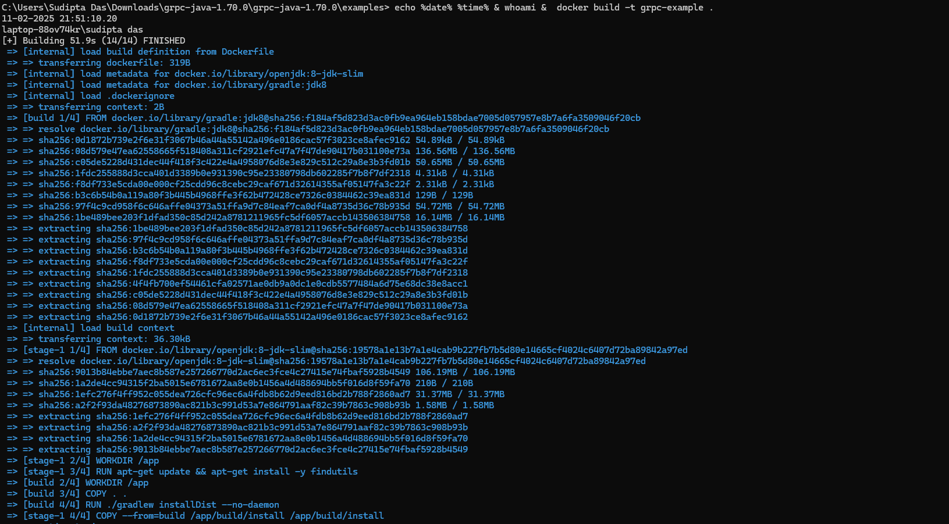

2. A Dockerfile is required to define the image configuration. The Dockerfile includes:

* A base image (openjdk )
* Copying source files into the container
* Compiling and running the Java gRPC server

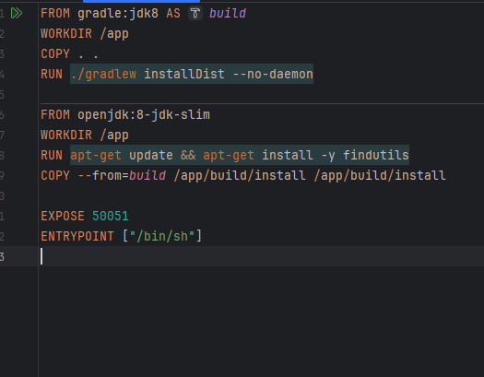

3. Once the image is built, we start the server container using docker run command.

-p 50051:50051 maps the container’s gRPC port to the host.



4. To interact with the server, we start the client container: --rm ensures the client container is removed after execution.

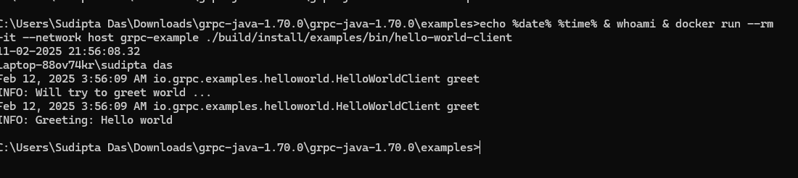

5. When modifying the server code ( adding a new RPC method), followed these steps

Edit HelloWorldServer.java.

Save the changes.

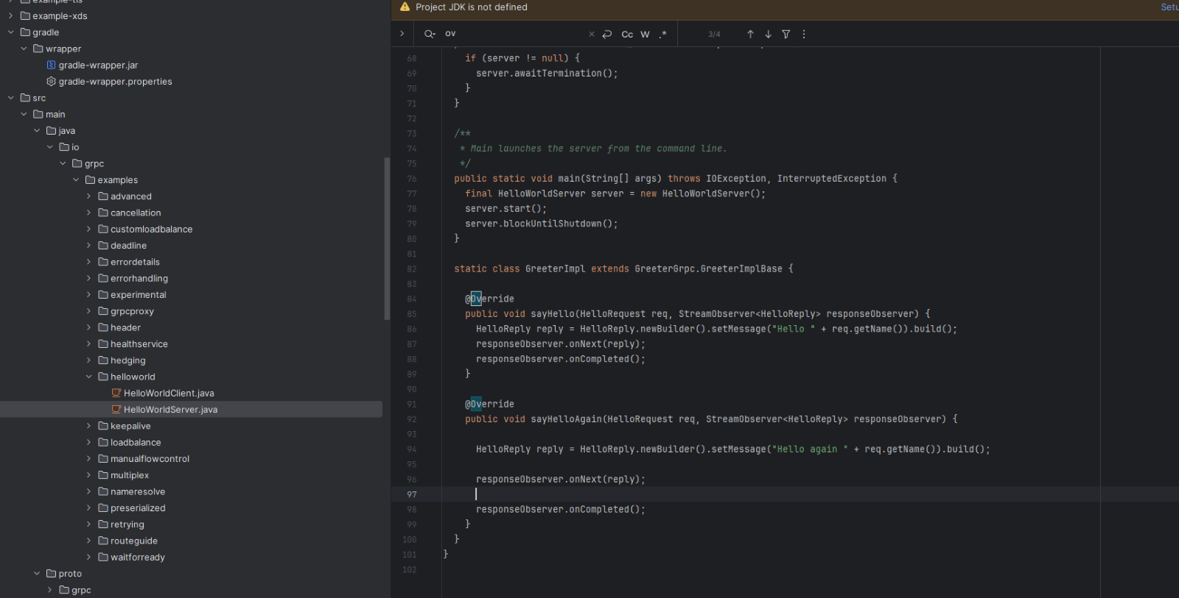

6. Updated the client-side code .

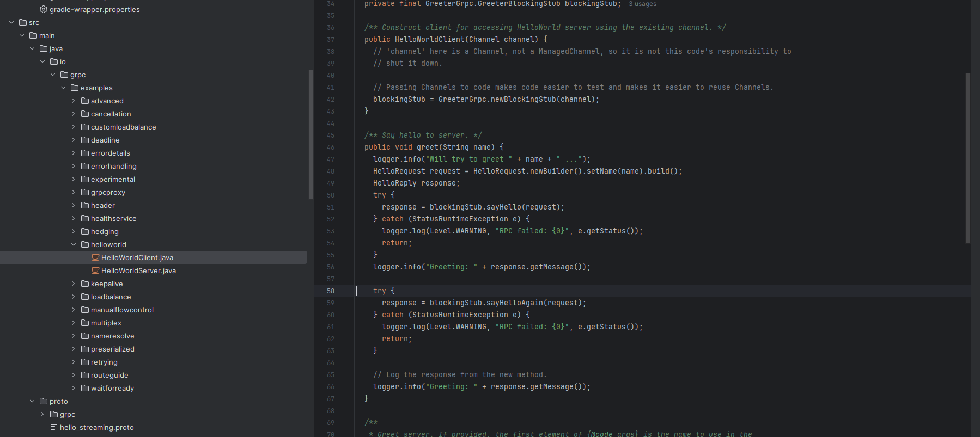

7. To apply the new changes, we need to build the image again  , and restart the server container:



8.To apply the new changes, we need to  restart the client container: We can see the output from the updated helloagain method.

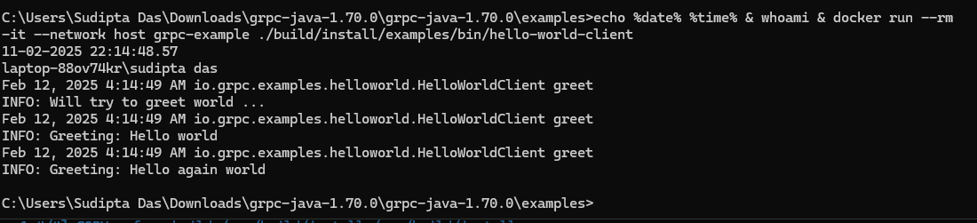

**Using Python: Completed by Olivia Le**

**Quick Start**

Create a new directory for your gRPC project and navigate into it:

mkdir grpc-python-docker && cd grpc-python-docker

Create a Dockerfile:

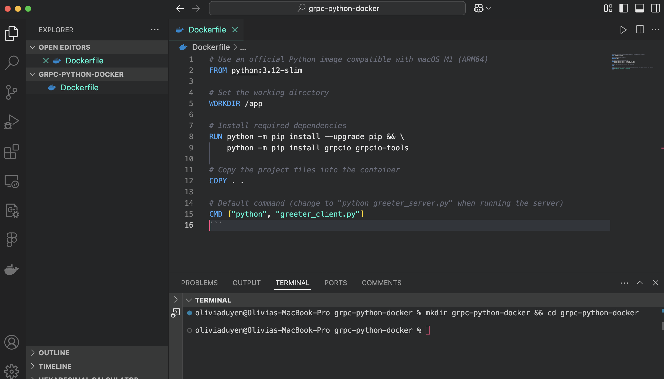

Clone the official gRPC example repository and navigate to the Python hello world example:

date; whoami; git clone -b v1.66.0 --depth 1 --shallow-submodules https://github.com/grpc/grpc

date; whoami; cd grpc/examples/python/helloworld

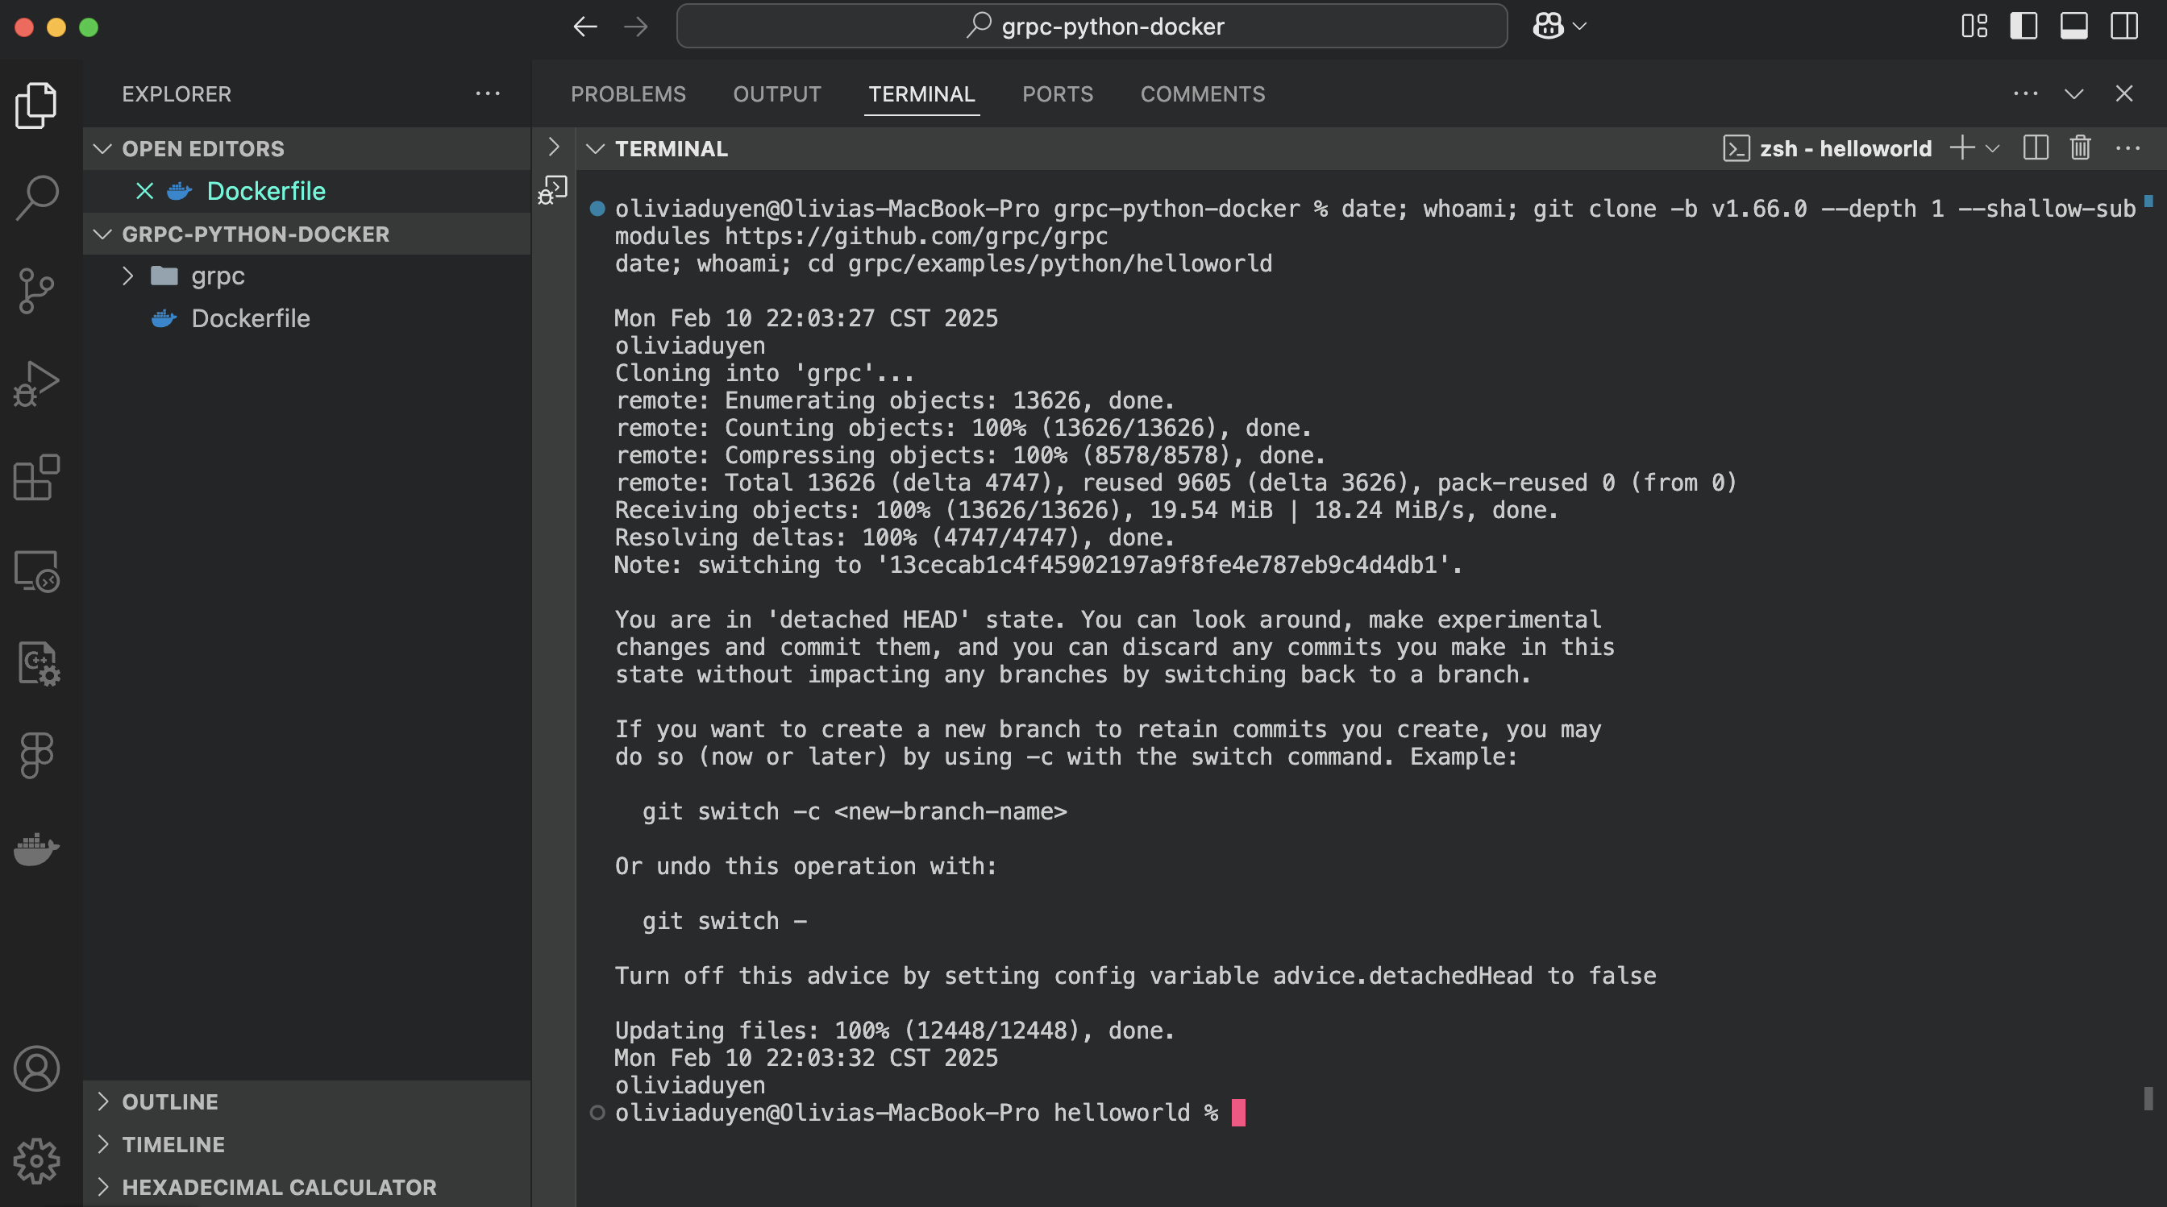

The docker build command:

date; whoami; docker build -t grpc-python .

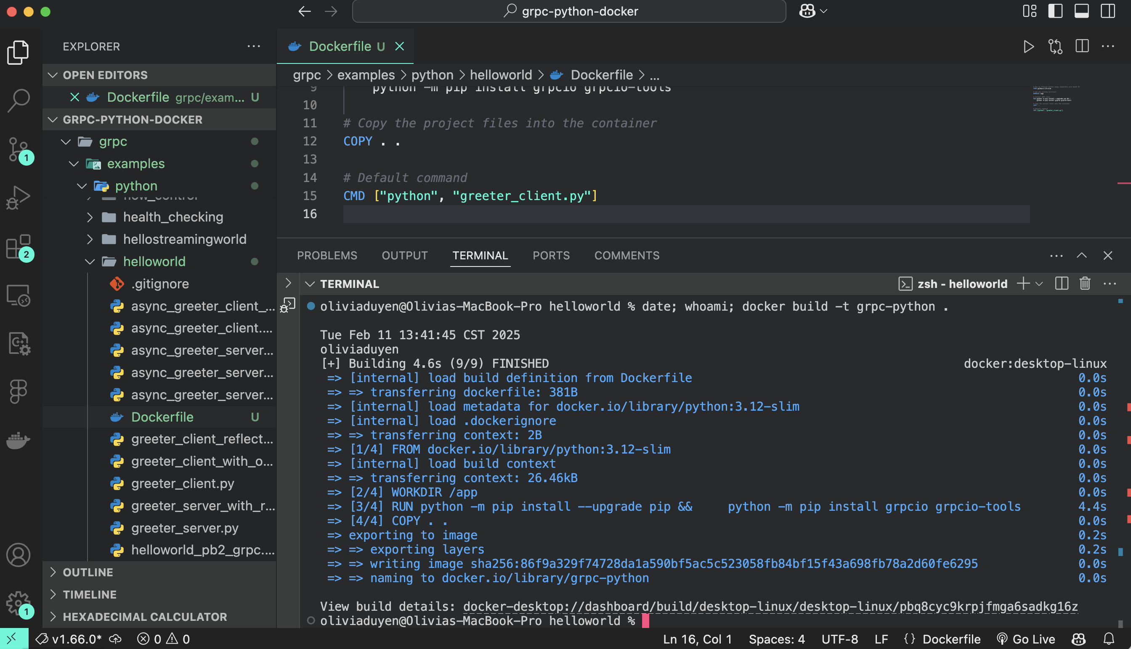

Run a gRPC application From the examples/python/helloworld directory:

Run the server:

date; whoami; docker run --rm -p 50051:50051 -v "$(pwd):/app" -w /app grpc-python python greeter_server.py

From another terminal, run the client:

date; whoami; docker run --rm --network host -v "$(pwd):/app" -w /app grpc-python python greeter_client.py

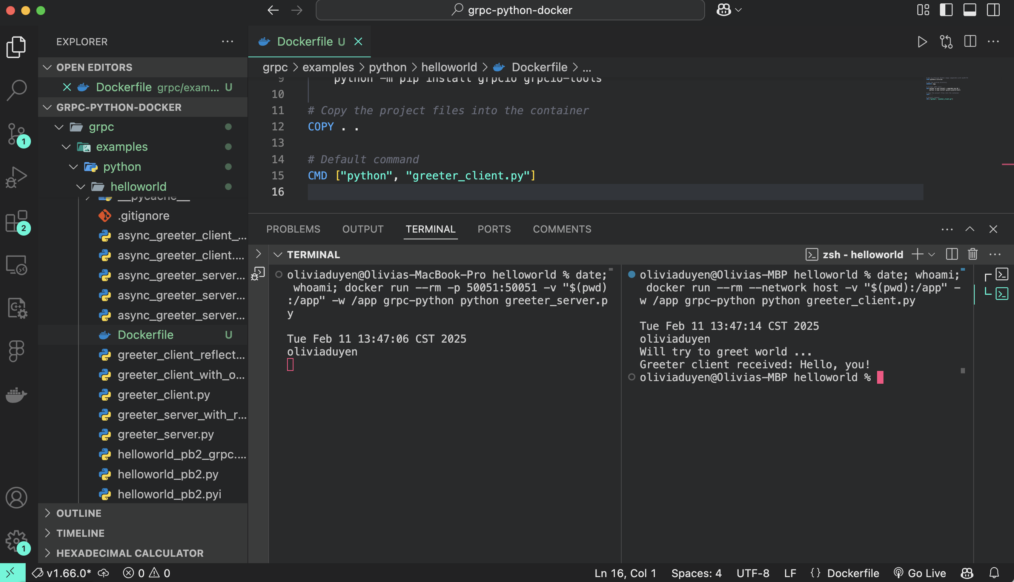

First navigate to the helloworld/ directory (where greeter_server.py and greeter_client.py are located):

cd /Users/oliviaduyen/grpc-python-docker/grpc/examples/python/helloworld

Run protoc Inside Docker with date; whoami;

Now run this command to generate the gRPC code:

date; whoami; docker run --rm -v "$(pwd):/app" -v "$(pwd)/../../protos:/protos" -w /app grpc-python \

sh -c "date; whoami; python -m grpc_tools.protoc -I/protos --python_out=. --pyi_out=. --grpc_python_out=. /protos/helloworld.proto"

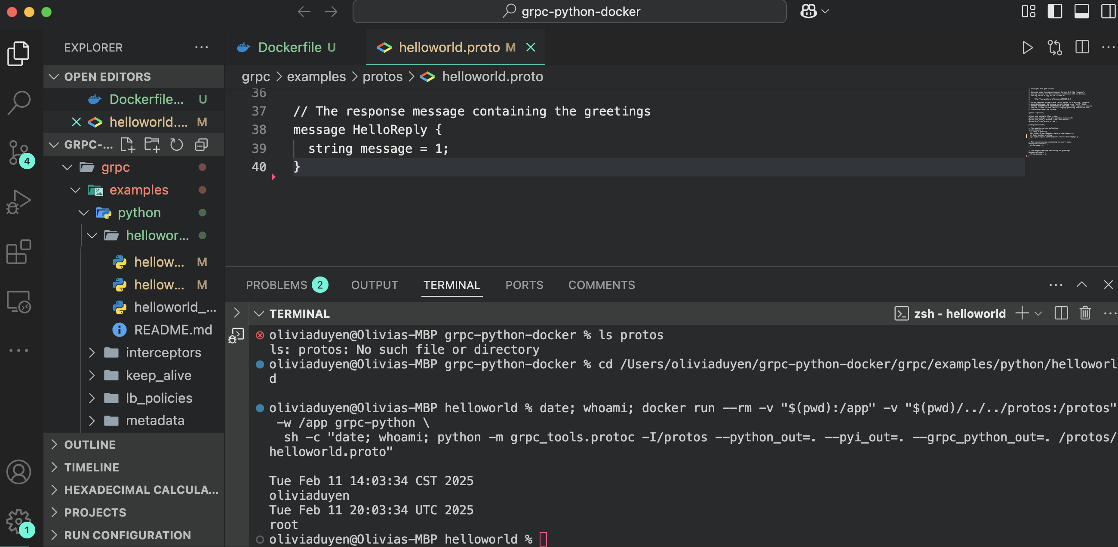

Update the server

In the same directory, open greeter_server.py. Implement the new method like this:

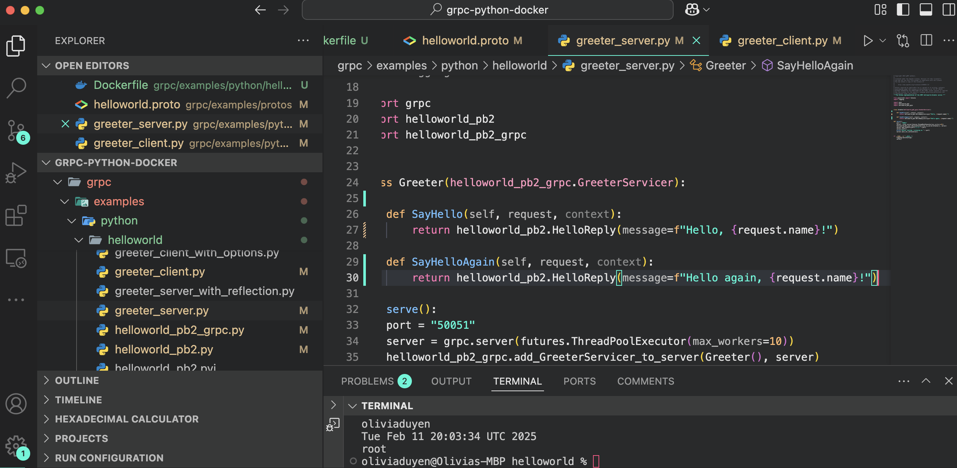

Update the client

In the same directory, open greeter_client.py. Call the new method like this:

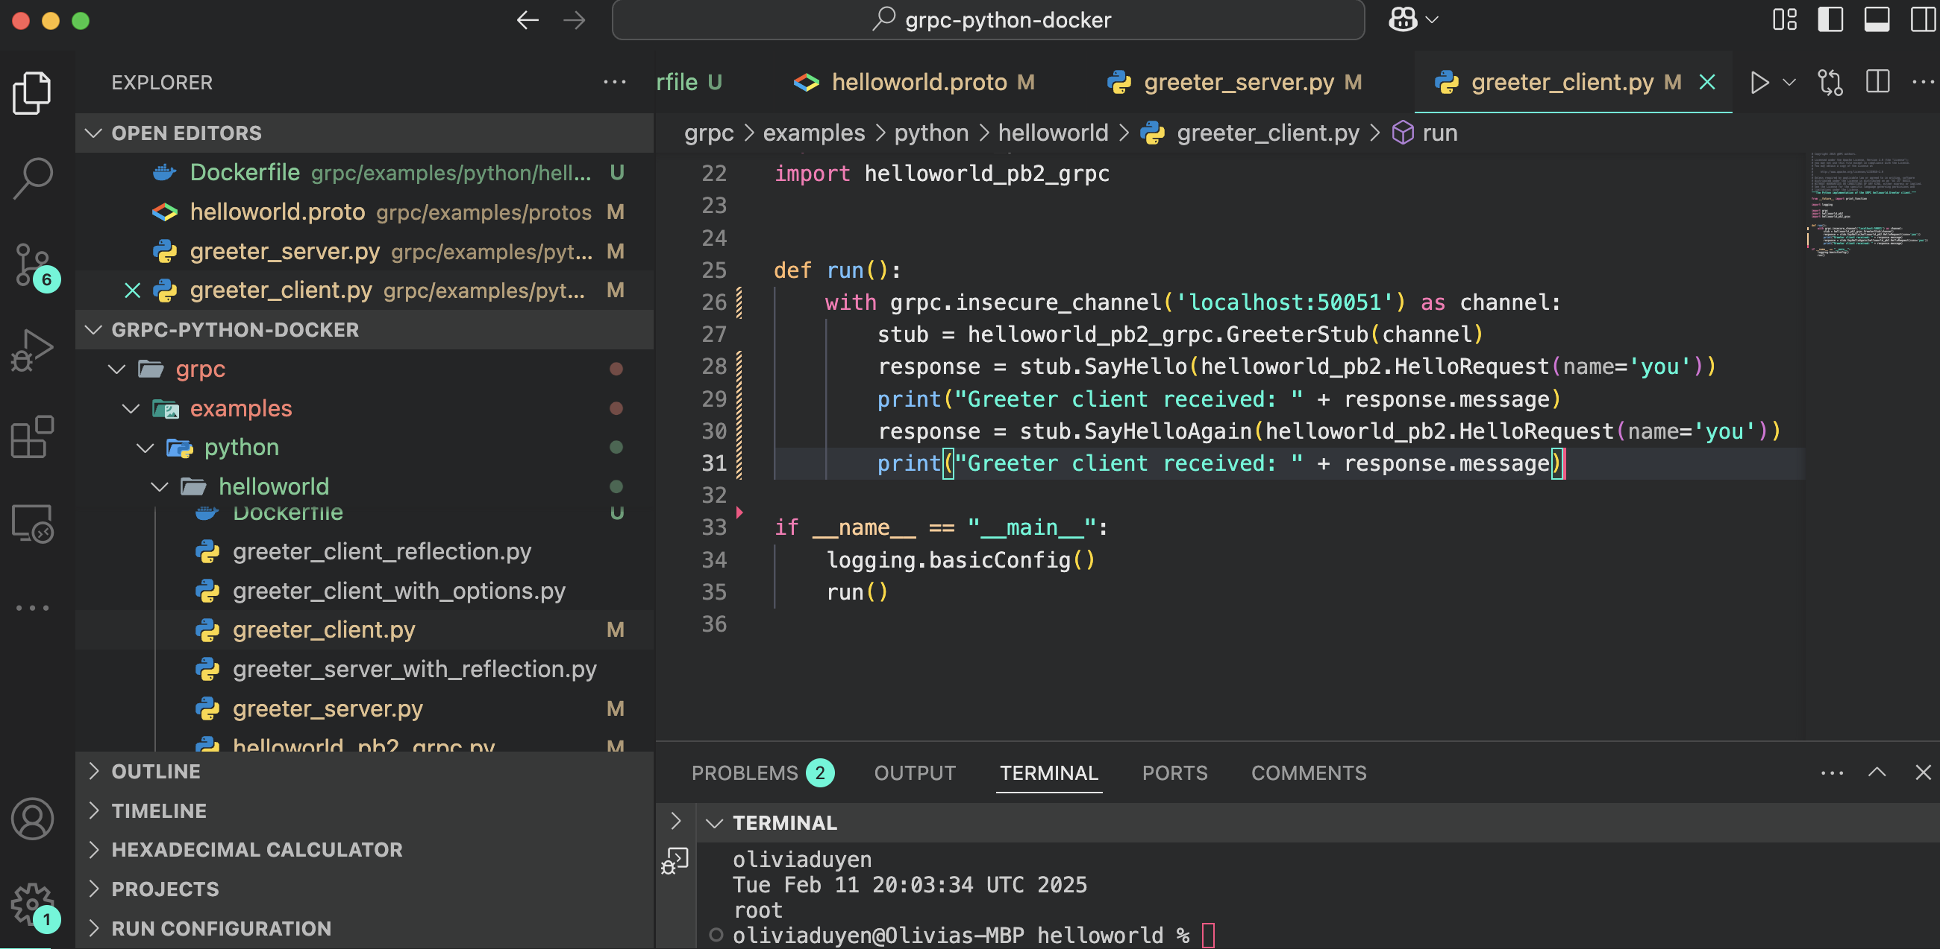

Run the server:

date; whoami; docker run --rm -p 50051:50051 -v "$(pwd):/app" -w /app grpc-python python greeter_server.py

From another terminal, run the client:

date; whoami; docker run --rm --network host -v "$(pwd):/app" -w /app grpc-python python greeter_client.py

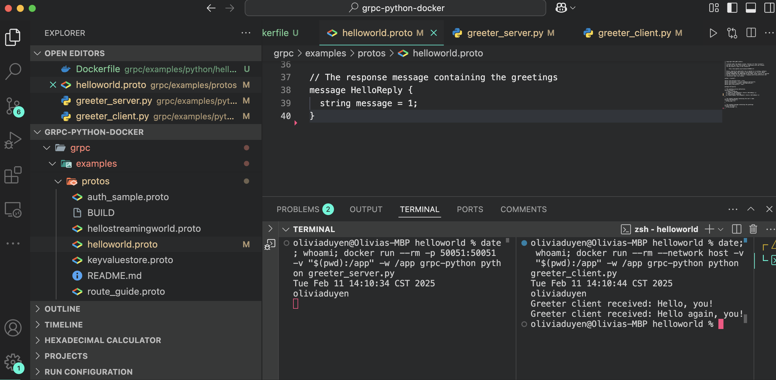

**Basic Tutorial**

Create a Dockerfile

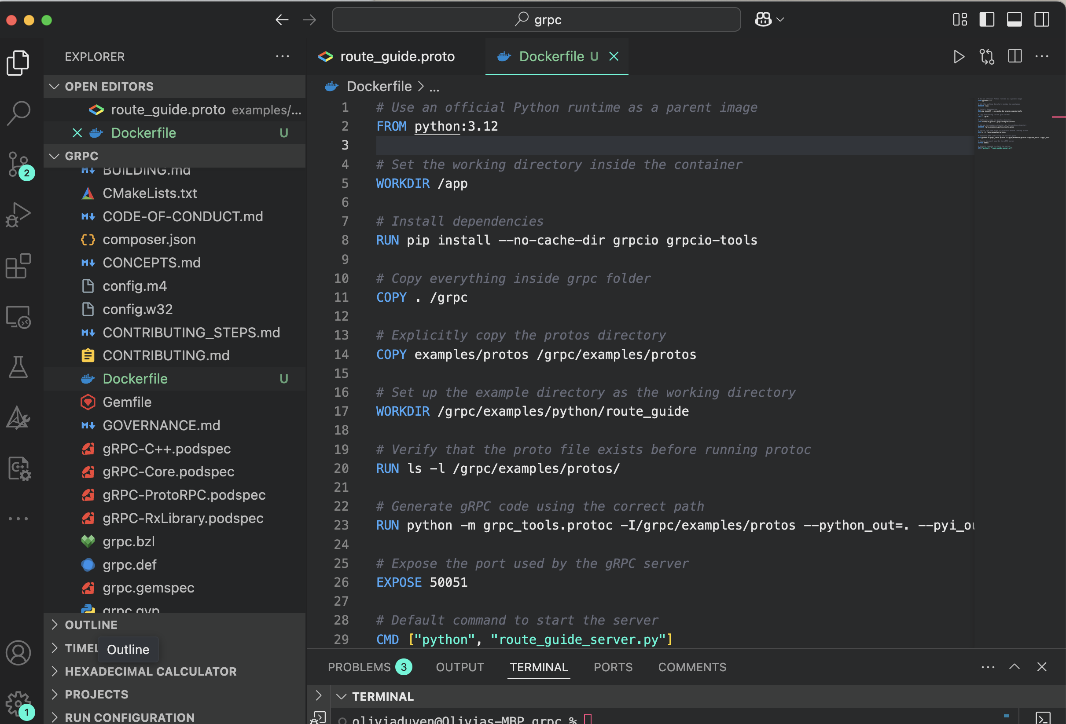

Build the Docker Image

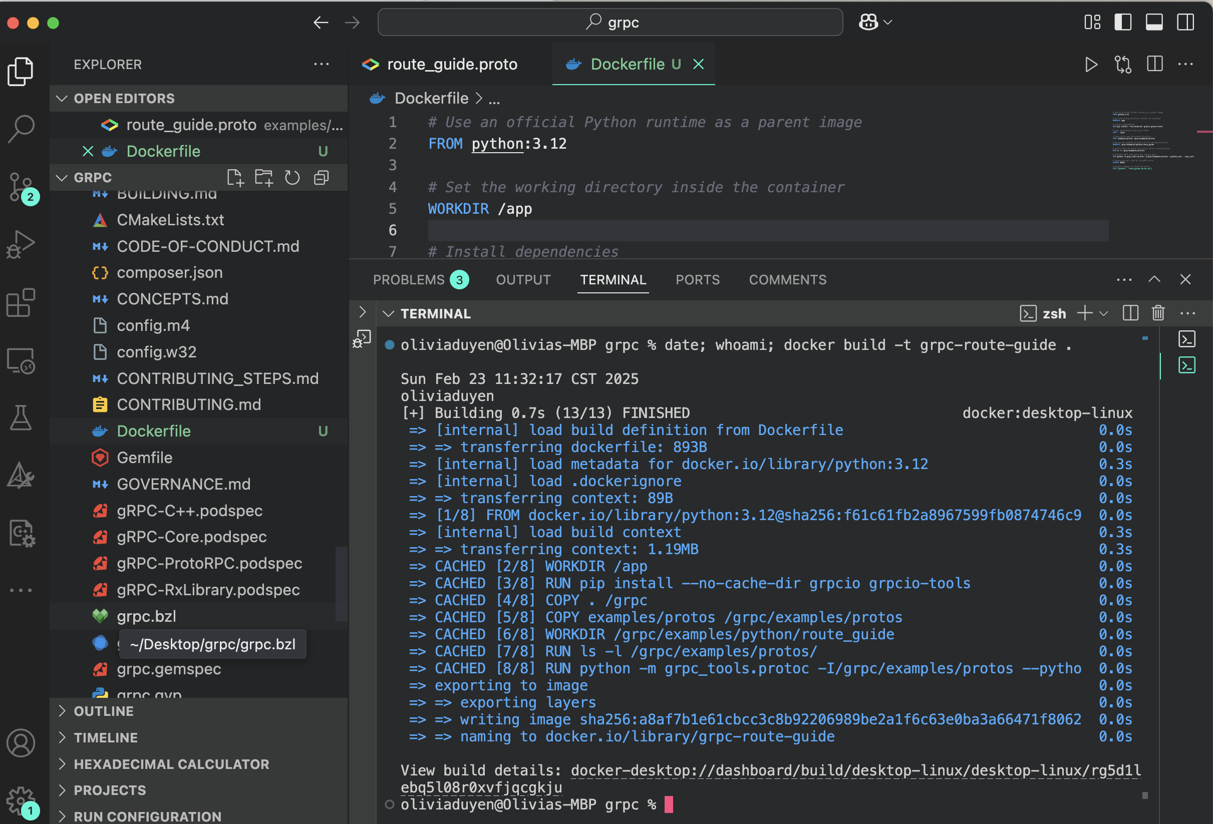

**Start the gRPC Server**

Run this in your terminal:

date; whoami; docker run --rm -p 50051:50051 --name grpc-server grpc-route-guide

**Open a New Terminal & Run the Client**

In a separate terminal, execute:

date; whoami; docker exec -it grpc-server python /grpc/examples/python/route_guide/route_guide_client.py

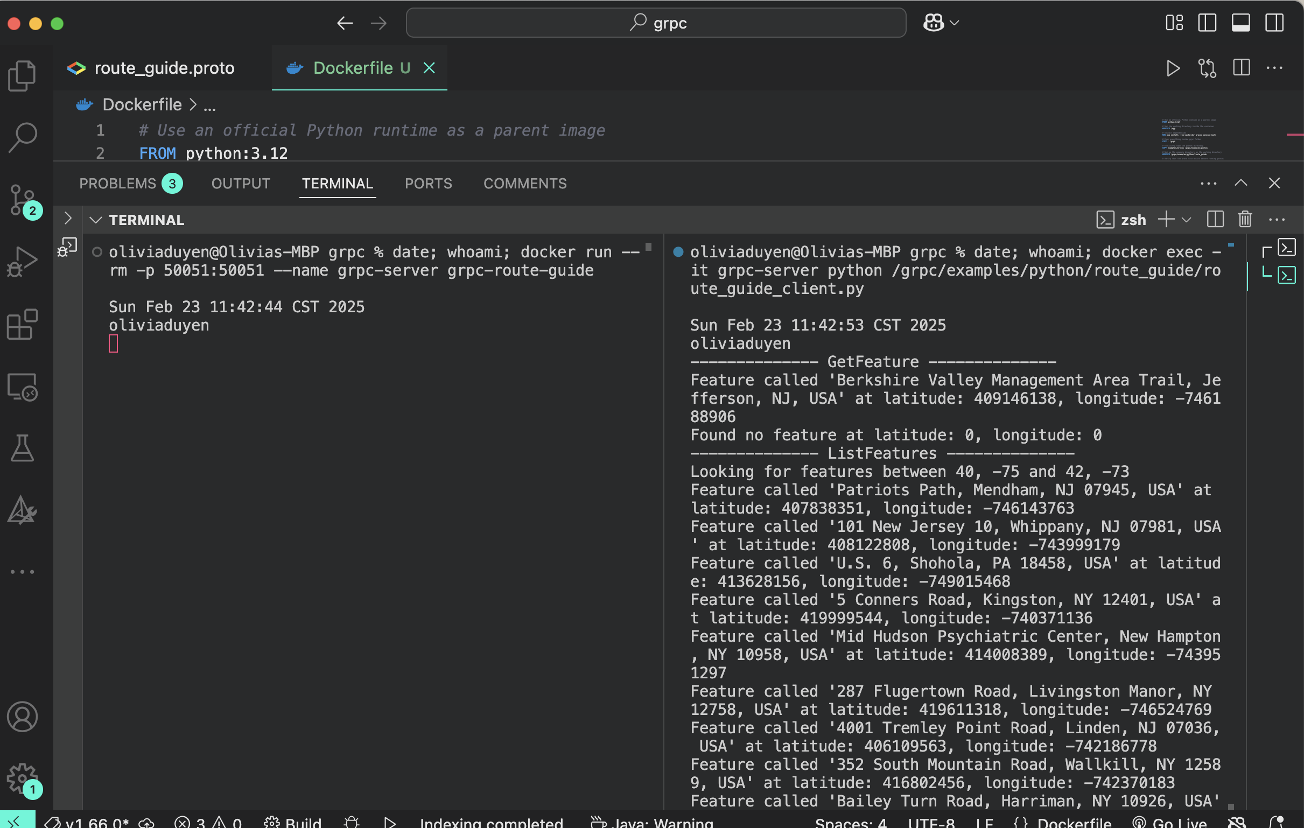

**Q3: Define services and message types for gRPC in proto file and implementation**

Implement two basic server-client pairs using the same proto file using python and java languages. Completed by Olivia Le.

**Q4: Define services and message types for gRPC in proto file and implementation**

Implement the Failure Detector Component of the SWIM protocol, using python language.

Completed by Olivia Le. The integration of failure component and dissemination component by invoking the notify failure method, is done by Sudipta Das

**Q5: Define services and message types for gRPC in proto file and implementation**

Implement the Dissemination Component of the SWIM protocol, using java language.

Completed by Sudipta Das. For question 4 and 5, the code and readme file in inside DsAssignment folder.

**Q6: Design & implement 5 different test cases**

Completed by Sudipta Das.

Building images:

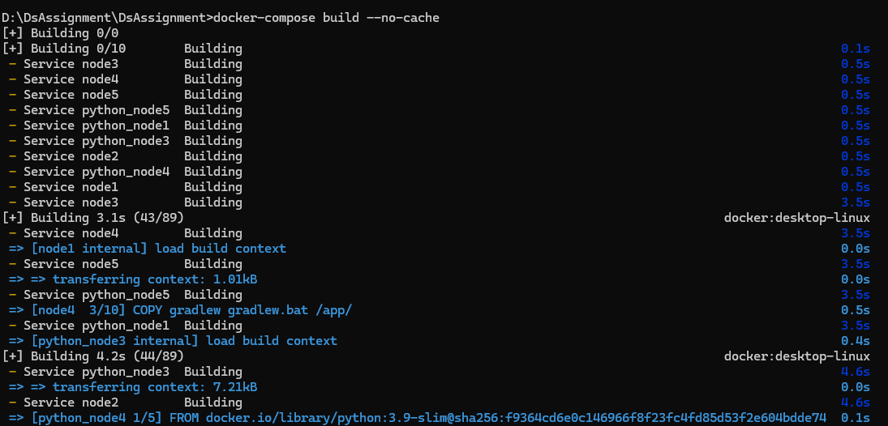

Test Scenario 1: Component Name: *Dissemination Component*  : Starting up the bootstrap node. In our scenario we have considered the node1 as bootstrap node.

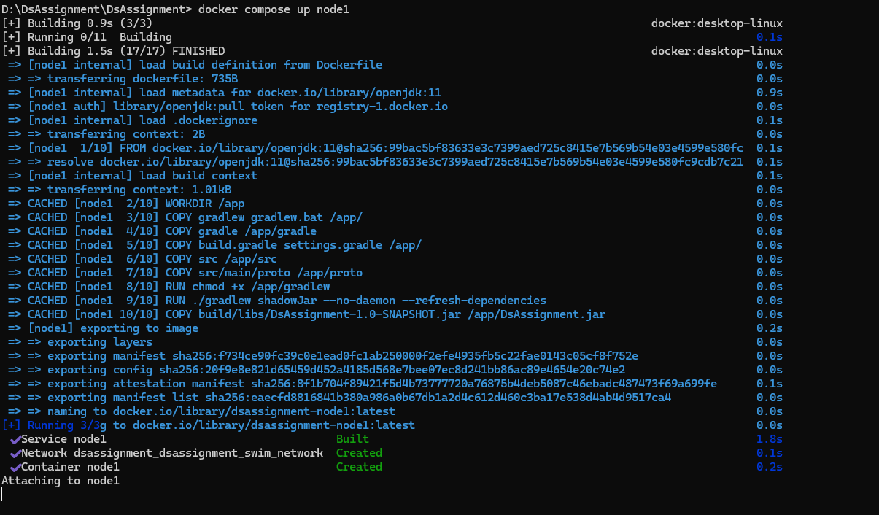

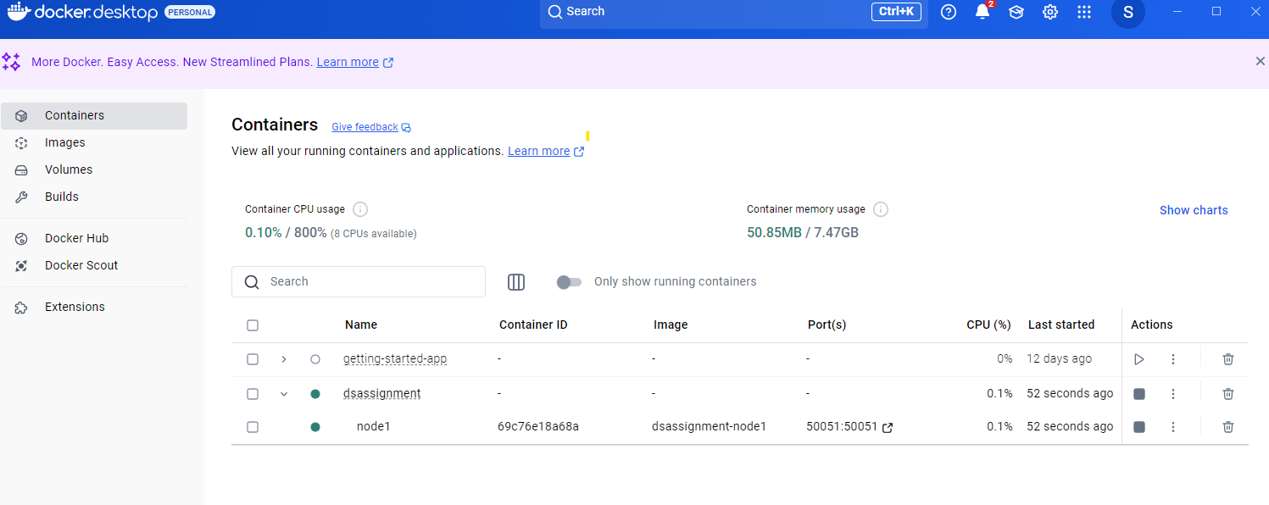

Test Scenario 2 : Dissemination Component  : Starting all others nodes (nodes 2 to nodes 5) . Each node will send a join request to the bootstrap node( node 1) . And bootstrap node will return the membership list .

Node 2 joins :

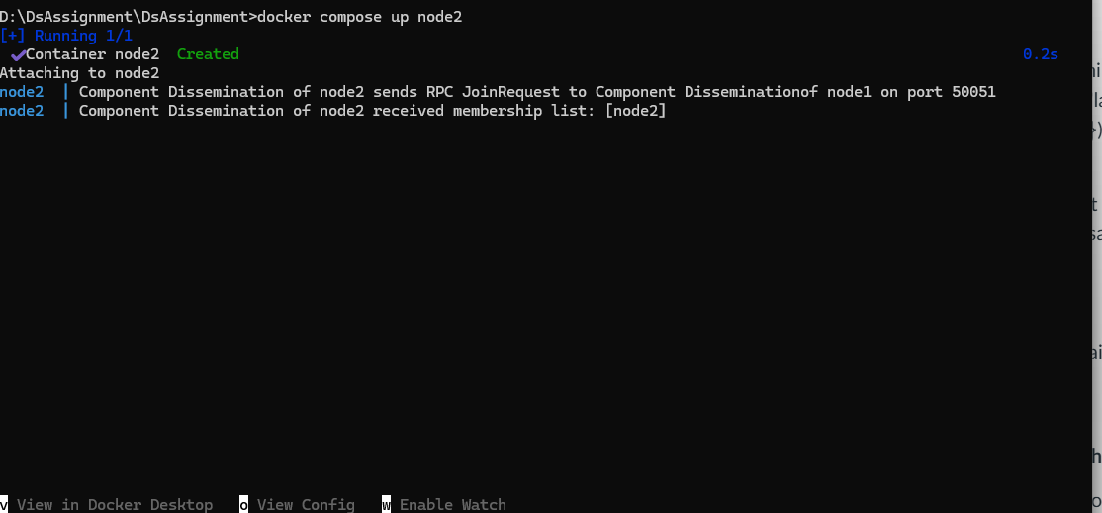

Node 3 joins :

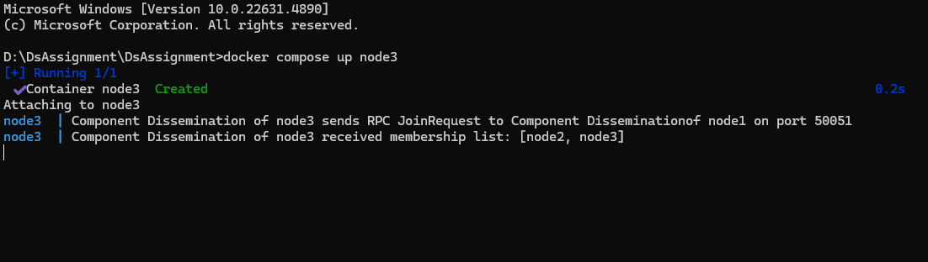

Node 4 joins:

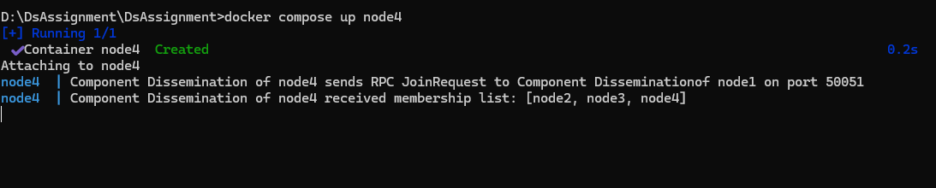

Node 5 Joins :

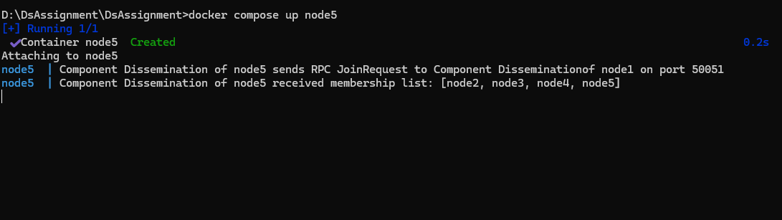

Logs in node1

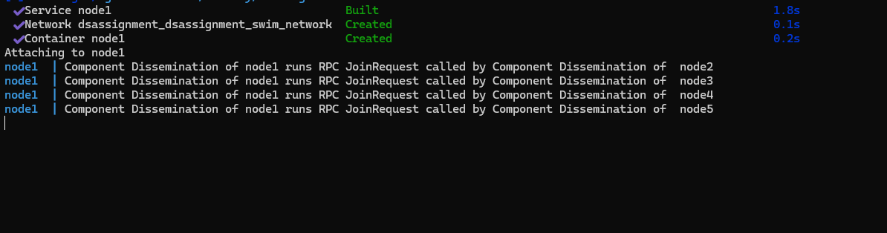

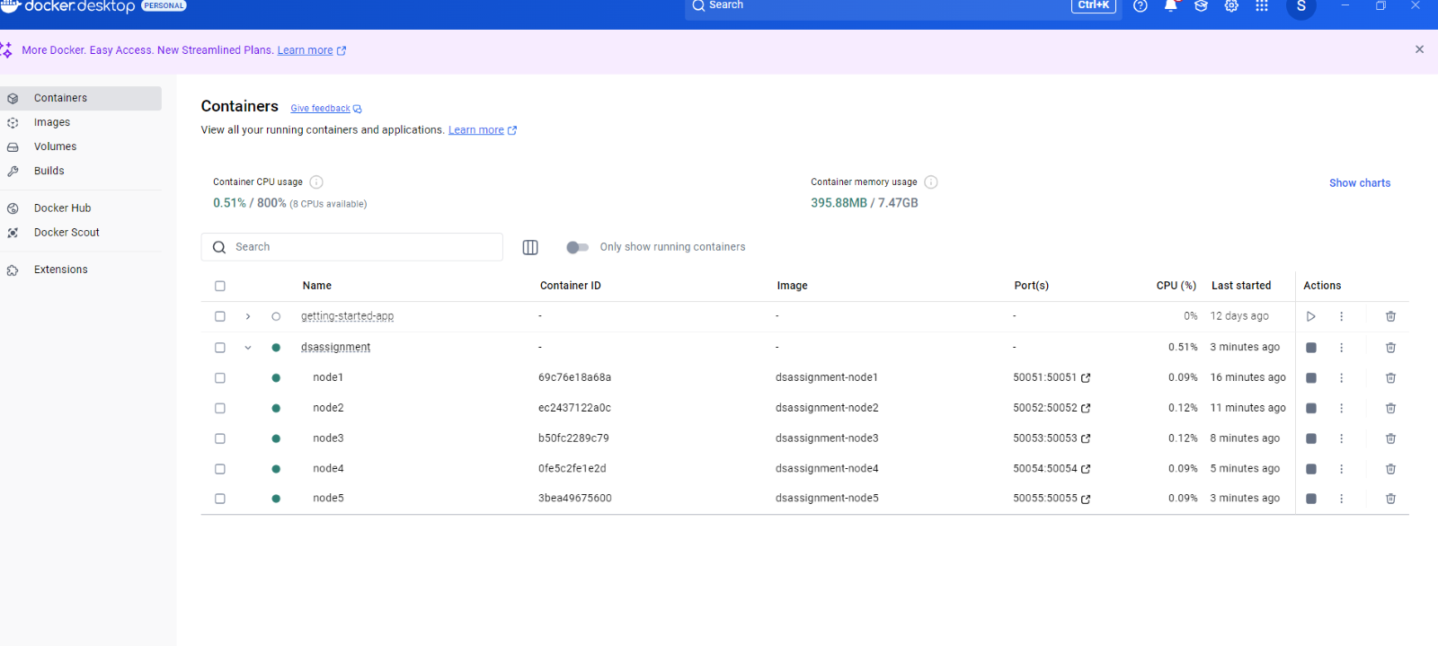

Test Scenario 3: Starting up the Failure Detector Components in the network:

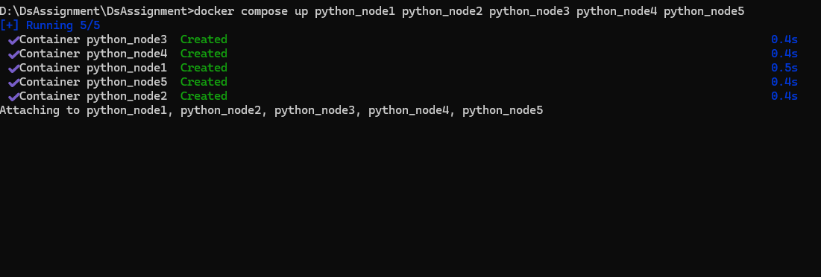

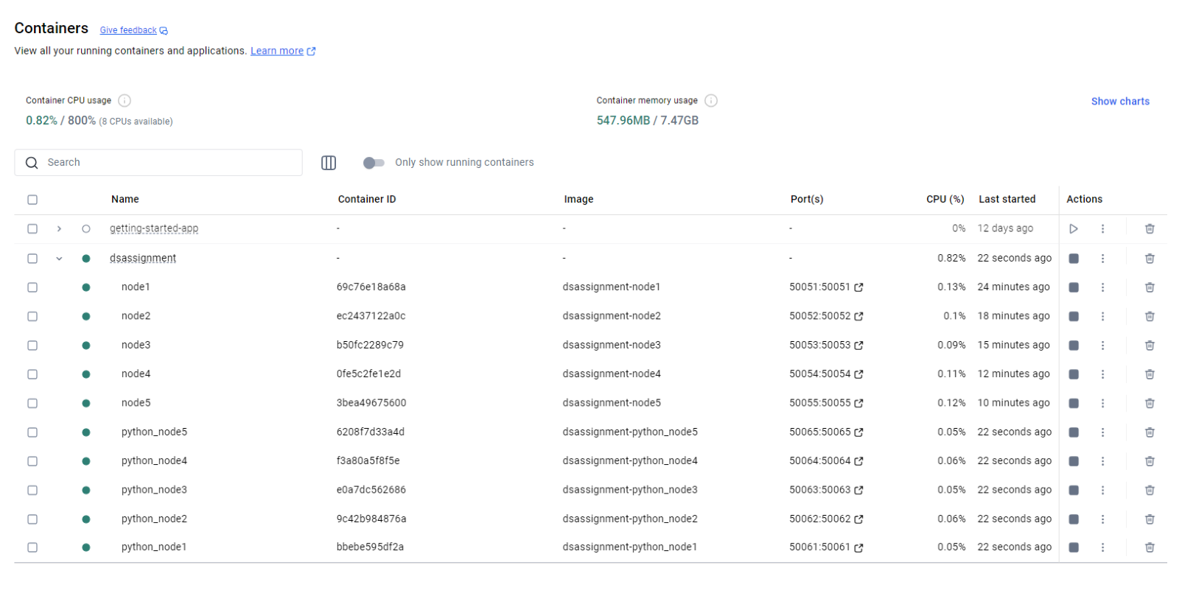

Test Scenario 4: The failure detector components of a node sends ping request to other randomly selected nodes  in its membership list:

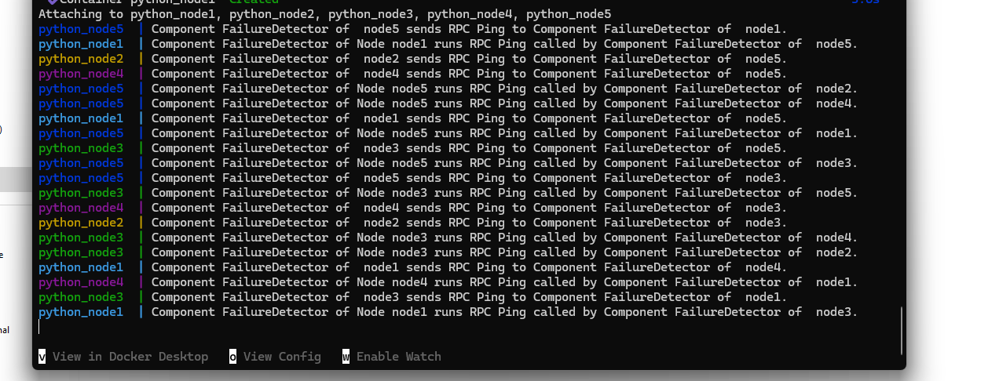

Logs from failure detector component of node2: 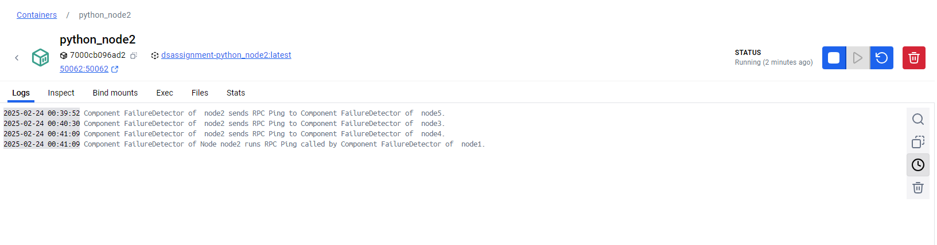

Logs from failure detector component of node 3:

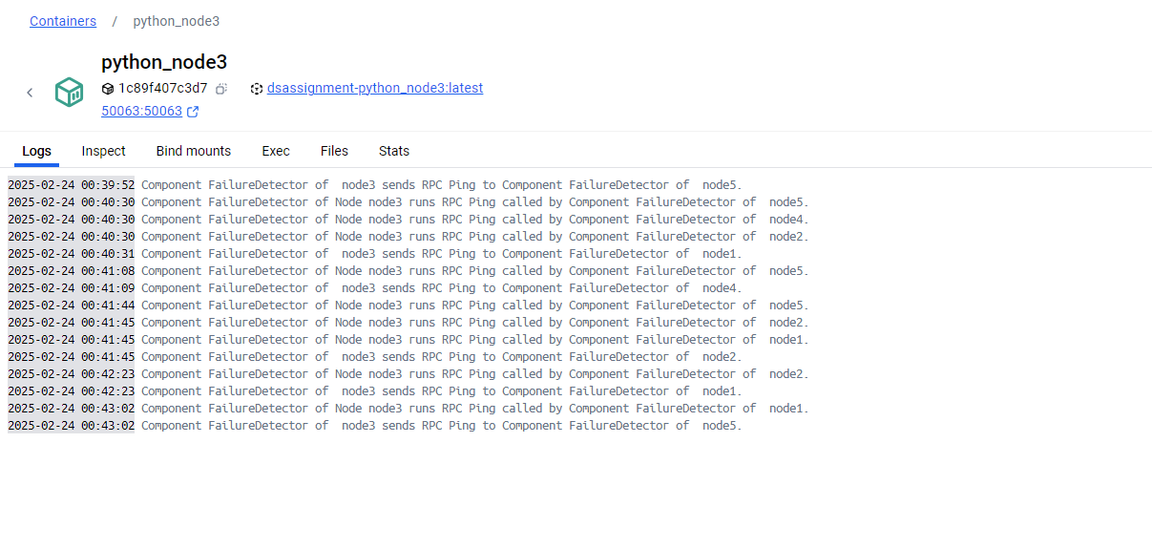

Test Scenario 5: node 2 fails, node 1 fails to ping node 2, it requests other nodes to ping node2. It gets failed response from other nodes (node 4, node 3)

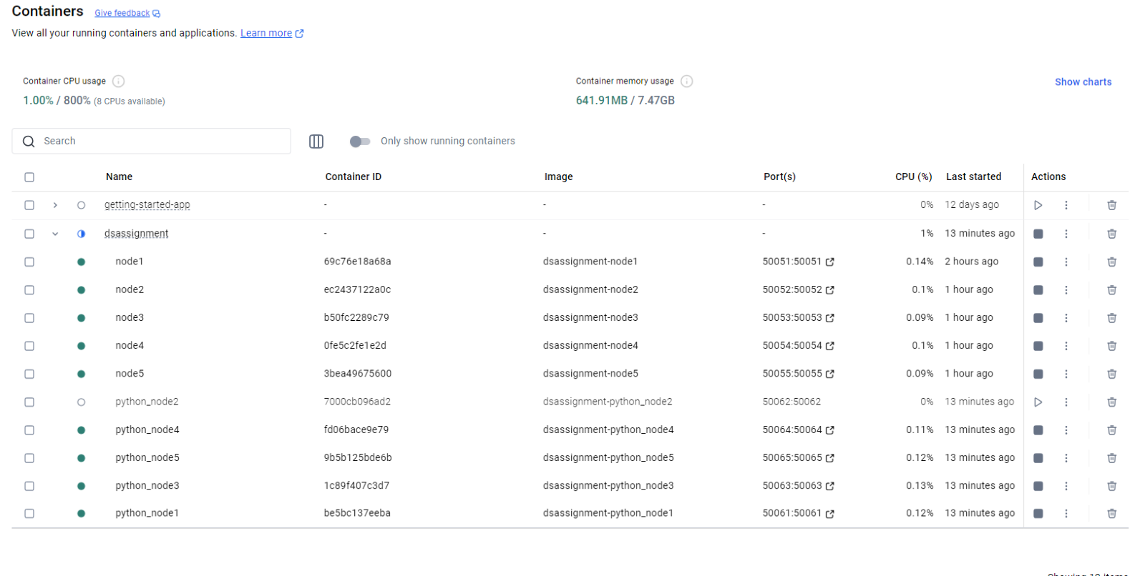

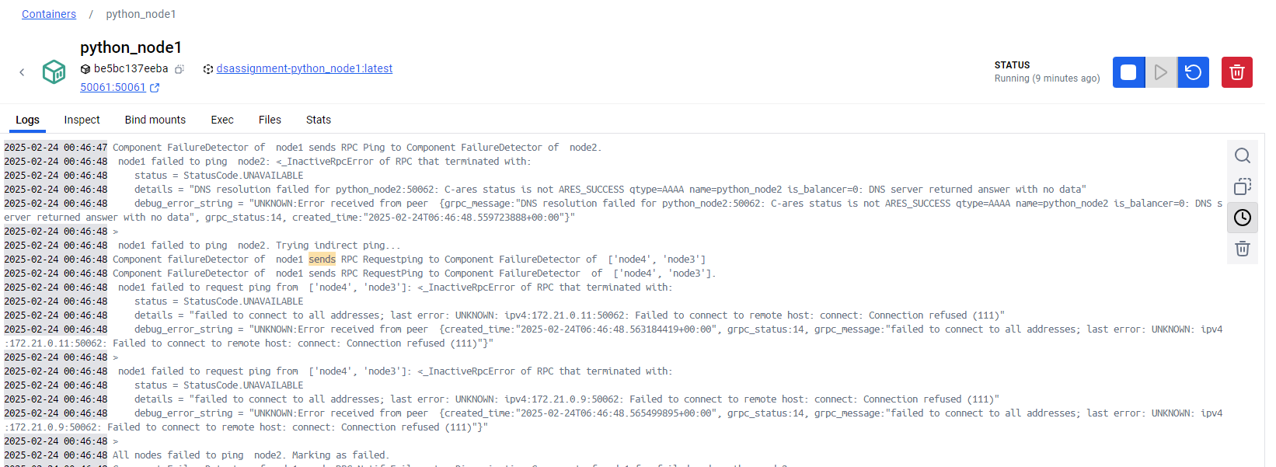

Failure detector component of node 1 send rpc notifyfailure to dissemination component of node 1.

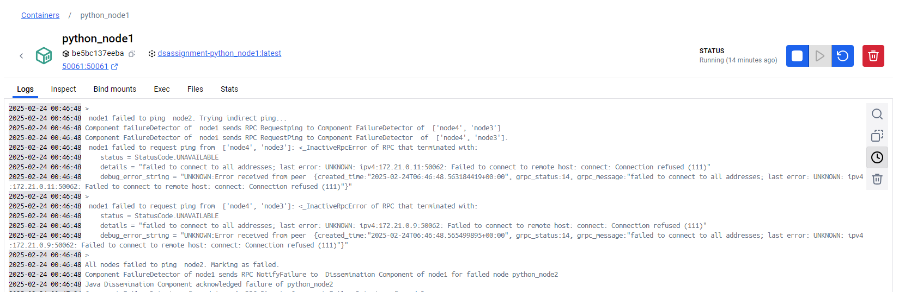

Test Scenario 6: On a different instance, I failed node 5 of failure component , and node 2 of failure component fails to ping node 5, then node 2 of failure component sends rpc notify failure to  dissemination component of node 2 :

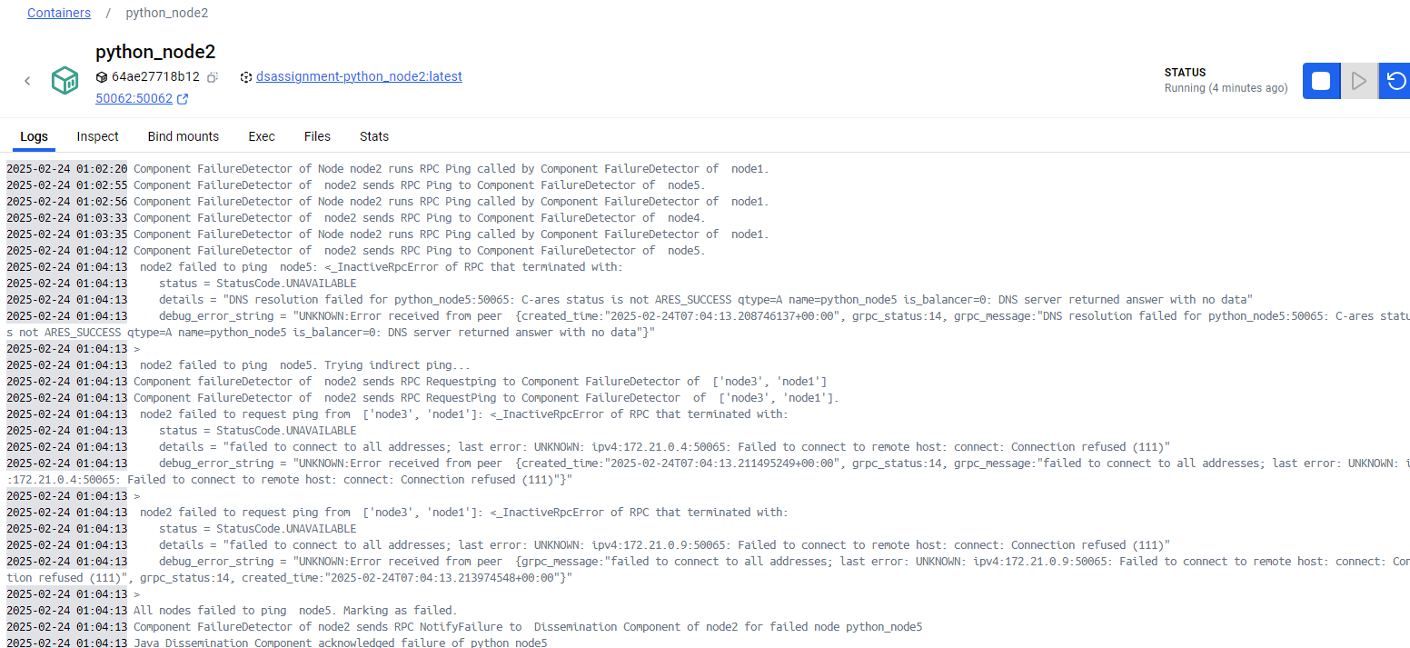

Node 2 of dissemination component multicasts the failure to its members list:

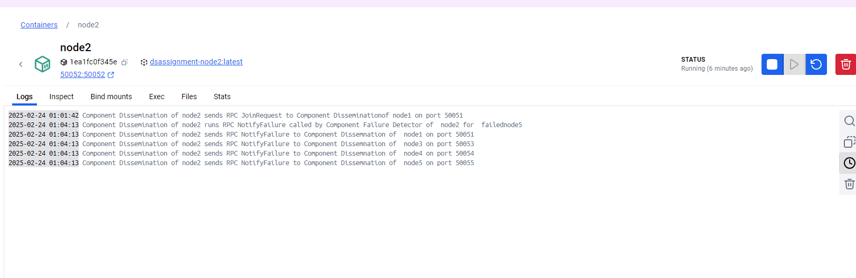

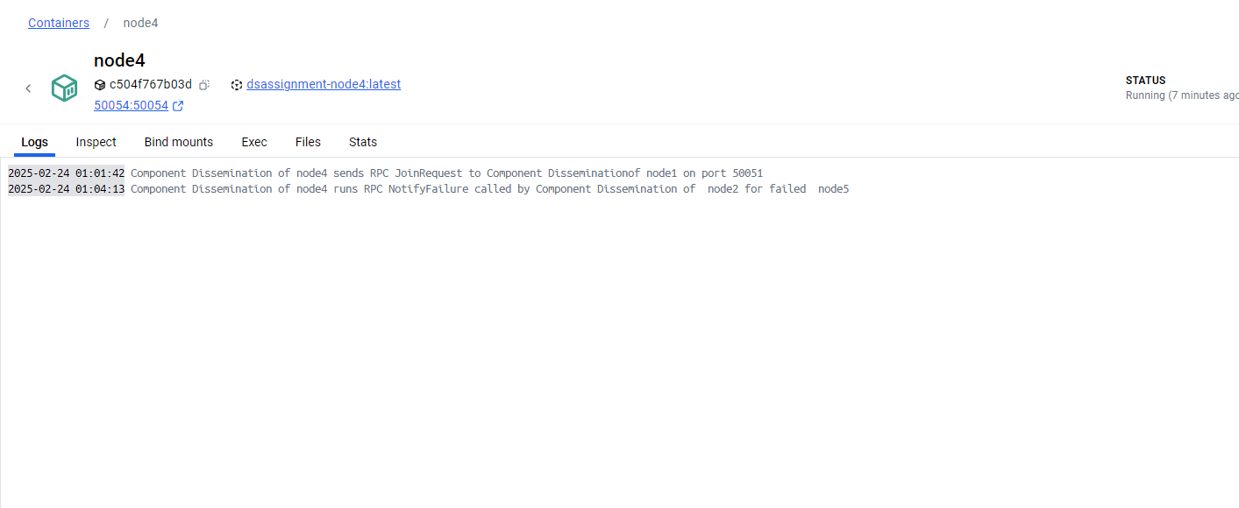

Here node 4 of dissemination component receives the multicast failure request from dissemination component of node 2

**README**

There is a README file inside grpc_q3 folder explaining how to compile and run the program.

There is a README file inside DsAssignment folder explaining how to compile and run the program q4 and q5.